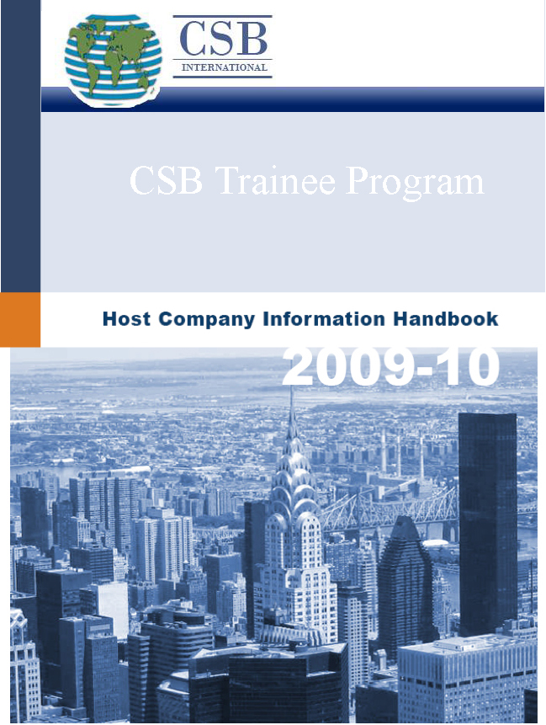



CSB International, Inc.
119 Cooper Street - Babylon, NY 11702
Toll Free: 866-822-1095 - Tel: 631-893-4540 - Fax: 631-893-4550

Dear Host Company,

Thank you for your interest in the CSB Trainee Program! The CSB Trainee Program is an Exchange Visitor Program under which young professionals from overseas have the opportunity to receive training in the United States.

The primary objectives of the CSB Trainee Program are to enhance the skills and expertise of foreign nationals in their academic or occupational fields through participation in a structured and guided work-based training program. The program strives to improve the participants’ knowledge of American techniques, methodologies, and expertise. The Trainee Program is also intended to increase participants’ understanding of American culture and society and to enhance Americans’ knowledge of foreign cultures and skills through an open interchange of ideas between participants and their American associates. A key goal of the Fulbright- Hays Act, which authorizes this program, is that participants will return to their home countries and share their experiences with their countrymen.

This Exchange Visitor Program, sponsored by CSB, is designed to foster international understanding by inviting young professionals to American businesses for up to 18 months. Throughout the training program, participants meet and train with U.S. professionals, improve their English proficiency, and gain greater insight into an American culture while enhancing Americans’ knowledge of foreign cultures.

SCB arranges programs for both trainees that have already secured a qualified host company and those trainees that are qualified for the program but need further assistance in locating a qualified host company.

The following manual will provide you with all the details necessary to understand the opportunities available in the CSB Trainee Program. We are excited to help you explore these wonderful opportunities and embark on the Trainee Program journey together.

Should you have any additional questions, do not hesitate to contact the CSB office at any time.

Respectfully yours,

Tanya Bykava
Trainee Program Manager

CSB International, Inc.
119 Cooper Street
Babylon, NY 11702
Phone: 631.893.4540
Fax: 631.893.4550
Toll Free: 866.822.1095
www.csb-usa.com

About CSB International

Founded in 1997, CSB is an exchange organization and a designated United States Department of State sponsor for the J-1 Trainee Program. Since its inception, CSB has worked with thousands of students and young professionals. Our goal is to provide quality assistance by giving personal attention and considering each detail of the exchange experience so as to allow every participant to grow intellectually through the exchange experience. Our mission begins with our local organizations, businesses and offices throughout the United States and extends to worldwide foreign facilities.

Globalize your workforce …

CSB invites you to participate in the Trainee Program at no cost to you! The CSB Trainee Program is fully participant-funded, with participant already covered with the required international health and travel insurance upon the arrival to the US. Join us in adding an international perspective to your workplace by training highly qualified and carefully screened young professionals.

A host company benefits from the cultural diversity that CSB trainees contribute to the workplace. The knowledge, enthusiasm and skills they bring with them from overseas are an invaluable addition to any business setting. Each host company will receive an added global perspective in the work environment by hosting an international J-1 trainee. Host companies will also have the benefit of bilingual or multilingual young professionals from different nations interacting with domestic employees and clients.

Every applicant accepted into the CSB Trainee Program has gone through an extensive screening process conducted by a CSB representative. Each selected trainee has demonstrated their enthusiasm, flexibility and eagerness to share their education and work experience with American businesses. Additionally, each selected trainee speaks English well enough to benefit from the training experience (the host company may conduct additional telephone interviews with trainees, if needed).

A return on your investment …

Like all organizational development programs, the CSB Trainee Program is a great investment in the future of your company. We offer you fantastic, young, foreign trainees who are focused on excellence in the workplace. The program allows the opportunity for you to train these young professionals locally and at the end of the program they will be free to return to their native countries to accept an opportunity to become full time members of your company’s international workplace. Your minimal investment of time and energy will lead to long-term results far beyond the norm as your overseas operations are insured a full complement of American trained multilingual employees.

The Role of a Host Company

A wide range of U.S. private businesses as well as and governmental and non-governmental entities open their doors to CSB trainees. A host organization is defined as US-based an organization that conducts training programs on behalf of CSB, pursuant to an executed written agreement between the two parties. In addition to an executed written agreement between CSB and the host organization, CSB assists all host organizations in developing a required Training Placement Plan (DS-7002) that outlines the experience to be provided to the trainee by the host organization.

Department of State Regulations strictly prohibit the use of the trainee program for ordinary employment purposes, stating in particular that CSB must not place trainee participants in positions that are filled or would be filled by full-time or part time employees. CSB is similarly forbidden from cooperating with any staffing/employment agencies in administering its Trainee Program. CSB also does not place trainees in unskilled or casual labor positions, in positions that require or involve childcare or elder care, or in clinical or any other kind of work that involves patient care or contact.

Training programs provided by US host organizations must not be used as substitutes for ordinary employment or work purposes; nor may they be used under any circumstances to displace American workers. Regulations for the Trainee Program are designed to distinguish between bona fide training, which is permitted, and merely gaining additional work experience, which is not permitted.

Host organizations that CSB has been cooperating with in the recent years include large, multinational organizations as well as small and medium-sized businesses across the United States. In all cases, the CSB Trainee Program has benefited our host companies in innumerable ways and many host organizations repeatedly organize training programs through CSB year after year.

Vetting of Host Companies

The goal of CSB in vetting host organizations is to collect sufficient evidence to make sure that
1). trainees receive quality training in the United States and 2).the US organizations hosting J-1 trainees meet the Trainee Program Regulations.

Department of State Regulations require that CSB verify that all host organizations are legitimate entities, are appropriately registered or licensed to conduct their activities in their jurisdiction, possess and maintain the ability and resources to provide structured and guided work-based experience according to the individualized Training Placement Plan (DS-7002) developed for each CSB trainee.

CSB must adequately screen all potential host organization by obtaining the following information:

- The Dun & Bradstreet identification number
- Employer Identification Number (EIN)
- Verification of telephone number, address, and professional activities via advertising, brochures, web site, and/or feedback from prior participants
- Verification of Workman’s Compensation Insurance Policy

In some instances, CSB will visit of the host organization’s training location. CSB must conduct site visits of host organizations that have not previously participated successfully in the CSB Trainee Program and that have fewer than 25 employees or less than three million dollars in annual revenue.

The Training Placement Plan (DS-7002)

The first step in the administration of the trainee program for all host organizations is to develop a detailed Training Placement Plan. Host organizations must sign a completed Form DS–7002 (Training Placement Plan) to verify that the placement is appropriate and consistent with the objectives of the trainees as outlined in their program applications. The Training Placement Plan must:
- State the specific goals and objectives of the training program (for each phase or component, if applicable)
- Detail the knowledge, skills, or techniques to be imparted to the trainee (for each phase or component, if applicable)
- Describe the methods of performance evaluation and the supervision (for each phase or component, if applicable)
- Be divided into specific and various phases or components. Each phase/component must:
- Describe the methodology of training
- Provide a chronology or syllabus.

CSB must also ensure that the duties of trainees as outlined in the Training Placement Plan will not involve more than 20 per cent clerical work, that trainees are trained at least 32 hour per week and that all tasks assigned to trainees are necessary for reaching the Trainee Program Objectives.

A sample of the DS-7002 is included on the following pages for your reference. This form is also available for downloading on the CSN website (www.csb-usa.com) or directly from the Department of State website at http://www.state.gov/documents/organization/84240.pdf
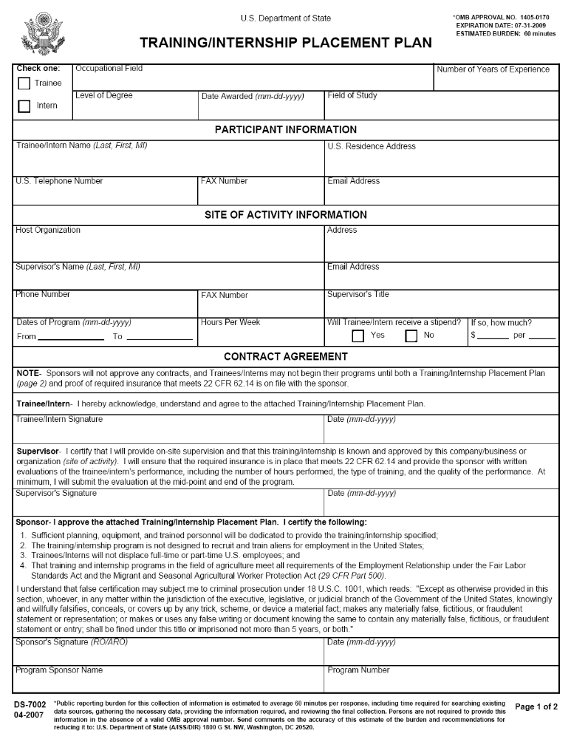
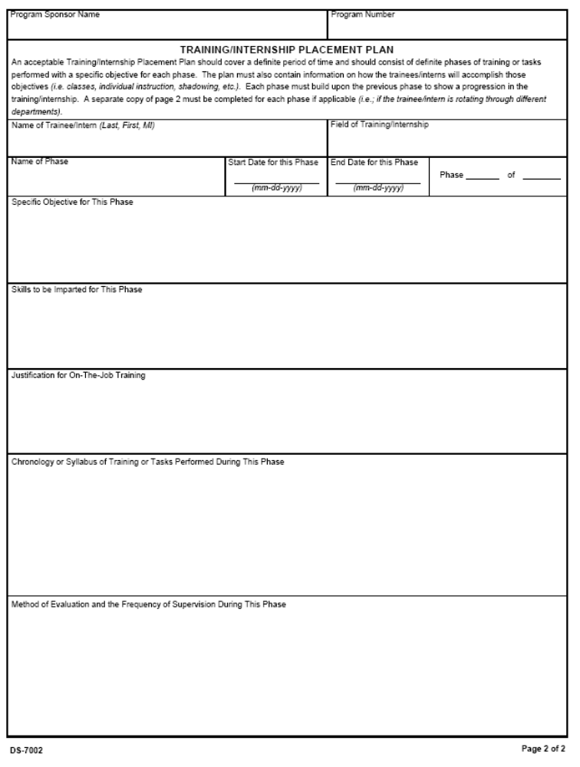
Trainee Stipend and Taxes

Trainee Program Regulations allow for compensation (stipend) to be given to the J-1 trainee for his/her time and effort. The host company will determine the amount of the stipend based on the nature of the trainee position, hours per week, geographical cost of living, and a comparable compensation for a similar position. This is the host company’s decision made independently of CSB.

The trainee’s passport and the form DS-2019 (Certificate of Eligibility) are both evidence of trainee’s lawful admittance to the United States under section 101(A) (15) (J) of the Immigration and Nationality Act. Participants will obtain Social Security Numbers for payroll purposes. Trainees must apply on their own behalf and in person at the local Social Security Office and present his/her passport with the I-94 card and the form DS-2019 (Certificate of Eligibility). Trainees can locate the nearest office by visiting the Social Security Administration website at http://www.ssa.gov. As proof of application they will be issued form SSA-5028. If the company wishes to prepare a report of earnings before the participant has received their Social Security card they may by leaving the space for the Social Security number blank. For information regarding Host Company responsibilities when engaging foreign personnel, please visit: http://www.ssa.gov/employer/hiring.htm

We would like to remind you that the CSB participants are exempt from Social Security, Medicare and Federal Unemployment taxes if they possess or obtain a sponsorship letter from CSB authorizing their training. {ref. Department of the Treasury, Internal Revenue Service, Circular E, Employer’s Tax Guide (page 31) section on students, scholars, trainees, teachers, etc., number 5}. (CSB issues the sponsorship letter for each student as part of the J-1 visa application packet). Please note that all CSB Trainee Program participants are subject to all applicable federal, state and local tax withholdings.

Program Termination

CSB, as the program sponsor, creates a record for each eligible trainee in the Student and Exchange Visitor Information System (SEVIS) database. CSB will maintain the trainee’s SEVIS record throughout the entire program duration. As proof of the SEVIS record creation, CSB will issue the form DS-2019 (Certificate of Eligibility) to each participant. The form DS-2019 identifies the program sponsor, the US host company, category of training and the duration of the program. Upon the receipt of the form DS-2019, CSB trainees are eligible to apply for a J-1 visa at the US consulate in their home country. Please note that the form DS-2019 does not guarantee the approval of the J-1 visa application; this is a decision made solely by the US consulate. If the visa application is approved, the trainee will receive a J-1 visa stamp in his/her passport and will be able to arrive within the following 2-4 weeks. The visa will be valid for up to 18 months, depending on the program duration, trainee’s country of citizenship and occupational category of training.

In the case that a serious situation arises with the participant, CSB must be notified immediately. CSB must be made aware of any serious situations involving CSB trainees in order to contact proper authorities, update trainee records and advise the host company of the appropriate course of action. There are several extreme situations that might mandate a trainee’s immediate dismissal from the program:
- Conviction of a crime
- Engaging in unauthorized employment
- Failure to pursue Exchange Visitor program activities
- Violation of any local, state or federal law
- Violation of any host company rules, regulations or codes of conduct

The trainee program end date is noted on the form DS-2019. However, in rare cases, a trainee’s SEVIS record may be terminated early due to extreme violations of the program. In all such cases, the trainee, and the US Host Company will be notified immediately. The trainee’s visa status will be annulled and the trainee must depart the United States immediately.

Following the successful completion of the J-1 trainee program, trainees are granted with additional 30 days (grace period), during which the participants may travel within the United States. Please note that no training or employment is allowed during the 30-day grace period.

RESPONSIBILITIES and OBLIGATIONS of HOST ORGANIZATION

Below, you will find a list of responsibilities and obligations outlined for all host organizations to follow. Please read the following responsibilities and obligations and sign below indicating that you understand and agree to these conditions.

- A Training Placement Plan (Form DS-7002) must be completed and signed by the Host Organization and the Trainee. The DS-7002 will verify that all placements are appropriate and consistent with the objectives of the trainee as outlined in his/her program application and as set forth in the Training Placement Plan.

- You understand that the participant is coming for a program of training and you understand the basic goals and objectives of this program.

- You understand that the maximum duration of this program is 18 months for Business Management programs, 12 months for Hospitality and Tourism programs and that the training position must be at least 32 hours of training per week.

- You agree that this training position will not displace an American employee.

- You understand that CSB is the participant’s exchange visitor program sponsor.

- You understand that the trainee is exempt from Federal Unemployment, Medicare and Social Security taxes but must pay all Federal, State and City Income taxes.

- You understand that the trainee must apply for a social security number.

- You understand host organizations must notify CSB promptly of any concerns about, changes in, or deviations from the Training Placement Plans during the training program and contact CSB immediately in the event of any emergency involving J-1 trainees.

- You understand that host organizations must abide by all Federal, State, and Local occupational health and safety laws.

- You understand that host organizations must abide by all program rules and regulations set forth by CSB and the US Department of State, including the completion of midterm and final program evaluations.

- Before CSB can issue the Form DS-2019, both the host organization and the trainee must fully complete and sign the Form DS–7002.

- You understand that CSB has the right to withdraw sponsorship from any participant who violates any rules or regulations or if the participant’s host organization willingly does not comply with program rules or regulations.

I UNDERSTAND AND AGREE TO THE CONDITIONS ABOVE.

Host Organization_________________________________________________________________

Name (print)____________________________________Title ________________________________

Signature_______________________________________Date_____________

Supervision and Evaluation

To monitor the trainee’s performance and overall progress, CSB requires trainee program evaluations (please refer to the following pages of this manual) to be submitted by the host company for each J-1 trainee. For programs exceeding six months in duration, a minimum of Midterm and Summative evaluations is required.

The required evaluations must be completed and submitted to CSB prior to the conclusion of the training program, and both the trainee and the immediate training supervisor must sign the evaluation forms.

CSB Trainee Program
Midterm Evaluation

Applicant’s Name:_____________________________________________________________

Evaluator’s Name:_____________________________________________________________

Company Name:______________________________________________________________

Please rate the applicant on a 1 to 10 scale, with 1 being the lowest and 10 being the highest, in the following areas. Please circle only one number.

- Attendance

1 2 3 4 5 6 7 8 9 10

- Completed Assigned Tasks on Time

1 2 3 4 5 6 7 8 9 10

- Productivity and Competence

1 2 3 4 5 6 7 8 9 10

- Mastered Required Competencies

1 2 3 4 5 6 7 8 9 10

- Would Recommend

1 2 3 4 5 6 7 8 9 10

Comments you have about the trainee:

Trainee’s Signature: _______________________________________ Date:_____________

Supervisor’s Signature: ____________________________________ Date:_____________
CSB Trainee Program
Summative Evaluation
(to be completed by the end of the training program)

Applicant’s Name ______________________________________________________

Evaluator’s Name ______________________________________________________

Company Name ______________________________________________________

Date ______________________________________________________

Please rate the trainee in the following categories with 1 being the lowest and 10 being the highest.

1. Attendance

1 2 3 4 5 6 7 8 9 10

2. Work Ethic

1 2 3 4 5 6 7 8 9 10

3. Positive Attitude

1 2 3 4 5 6 7 8 9 10

4. Willingness to Listen to Suggestions

1 2 3 4 5 6 7 8 9 10

5. Mastered Required Competencies

1 2 3 4 5 6 7 8 9 10

Please list major skills the trainee has attained and rate each skill as to the level of required competency with 1 being the lowest and 10 being the highest.

1. ____________________________

1 2 3 4 5 6 7 8 9 10

2. ____________________________

1 2 3 4 5 6 7 8 9 10

3. ____________________________

1 2 3 4 5 6 7 8 9 10

4. ____________________________

1 2 3 4 5 6 7 8 9 10

5. ____________________________

1 2 3 4 5 6 7 8 9 10

List any major recommendations to the trainee for improvement in attaining skills.

Would you recommend this trainee for further employment and why?

CSB Approved Trainee Categories:

Management, Business, Commerce and Finance

Hospitality and Tourism

Related Subjects/Fields:

Accounting
Accounting and Business/Management
Accounting and Finance
Accounting and Related Services, Other
Apparel and Accessories Marketing Operations
Auctioneering
Auditing (NEW)
Banking and Financial Support Services
Business Administration and Management, General
Business Administration, Management and Operations, Other
Business Operations Support and Secretarial Services, Other
Business Statistics
Business and Personal/Financial Services Marketing Operations
Business, Management, Marketing, and Related Support Services, Other
Business/Commerce, General
Business/Corporate Communications
Business/Managerial Economics
Construction Management
Credit Management
Customer Service Management
Customer Service Support/Call Center/Teleservice Operation
E-Commerce/Electronic Commerce
Entrepreneurial and Small Business Operations, Other
Entrepreneurship/Entrepreneurial Studies
Fashion Merchandising
Fashion Modeling
Finance and Financial Management Services, Other
Finance, General
Financial Planning and Services
Franchising and Franchise Operations
General Merchandising, Sales, and Related Marketing Operations, Other
Hospitality Administration/Management, General
Hospitality Administration/Management, Other
Hospitality and Recreation Marketing Operations
Hotel/Motel Administration/Management
Human Resources Development
Human Resources Management and Services, Other
Human Resources Management/Personnel Administration, General
Information Resources Management/CIO Training
Insurance
International Business/Trade/Commerce
International Finance
International Marketing
Investments and Securities
Knowledge Management
Labor Studies
Labor and Industrial Relations
Logistics and Materials Management
Management Information Systems and Services, Other
Management Information Systems, General
Management Science, General
Management Sciences and Quantitative Methods, Other
Marketing Research
Marketing, Other
Marketing/Marketing Management, General
Merchandising and Buying Operations
Non-Profit/Public/Organizational Management
Office Management and Supervision
Operations Management and Supervision
Organizational Behavior Studies
Parts, Warehousing, and Inventory Management Operations
Public Finance
Purchasing, Procurement/Acquisitions and Contracts Management
Real Estate
Resort Management
Restaurant/Food Services Management
Retailing and Retail Operations
Sales, Distribution, and Marketing Operations, General
Selling Skills and Sales Operations
Small Business Administration/Management
Special Products Marketing Operations
Specialized Merchandising, Sales, and Related Marketing Operations
Taxation
Tourism Promotion Operations
Tourism and Travel Services Management
Tourism and Travel Services Marketing Operations
Traffic, Customs, and Transportation Clerk/Technician
Transportation/Transportation Management
Vehicle and Vehicle Parts and Accessories Marketing Operations
